Three Political Cartoons
Student’s Name
Instructor’s Name
Institutional Affiliation

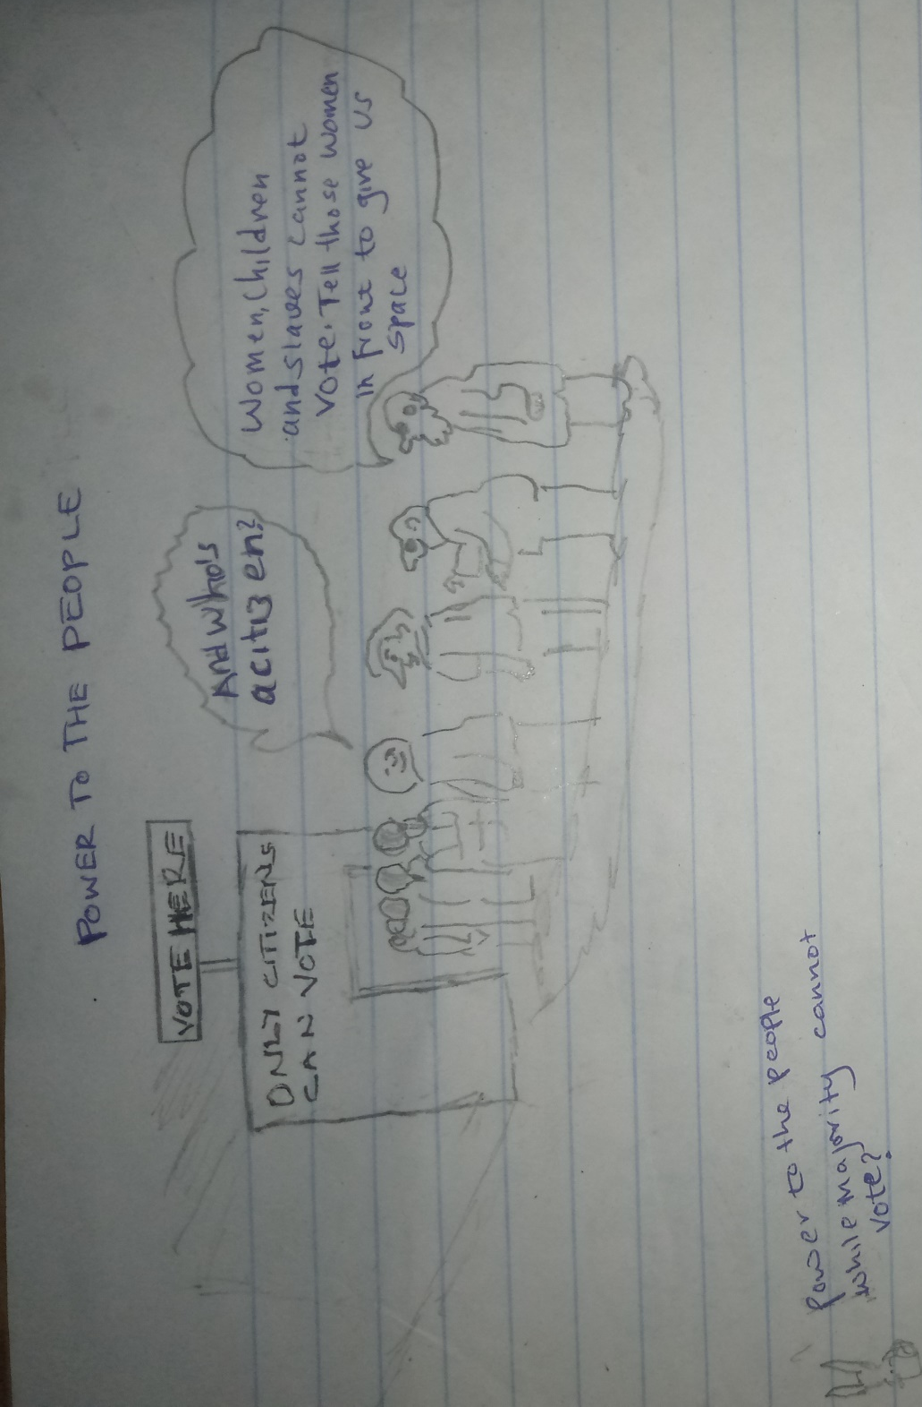
Fig 1: Carton critiquing direct democracy in Ancient Athens

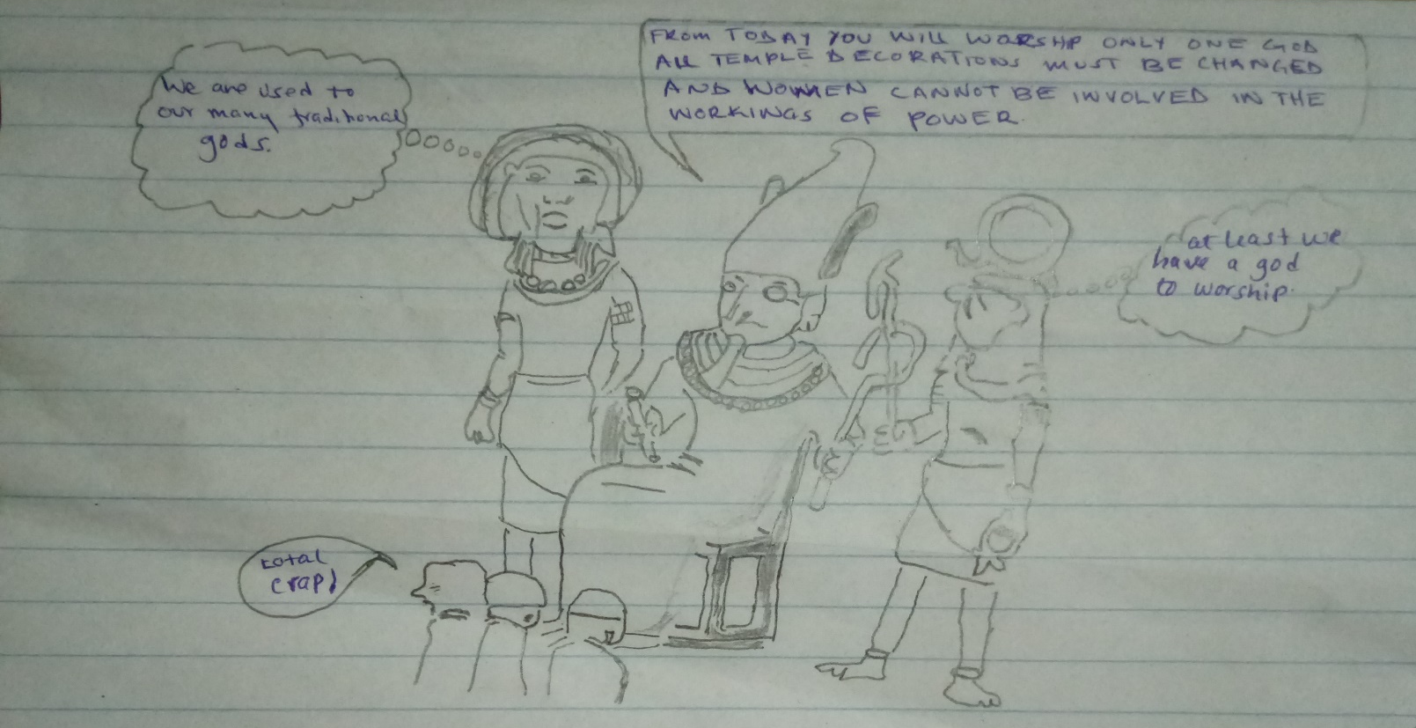
Fig 2: Carton critiquing Akhenaton’s New Religion in Egypt
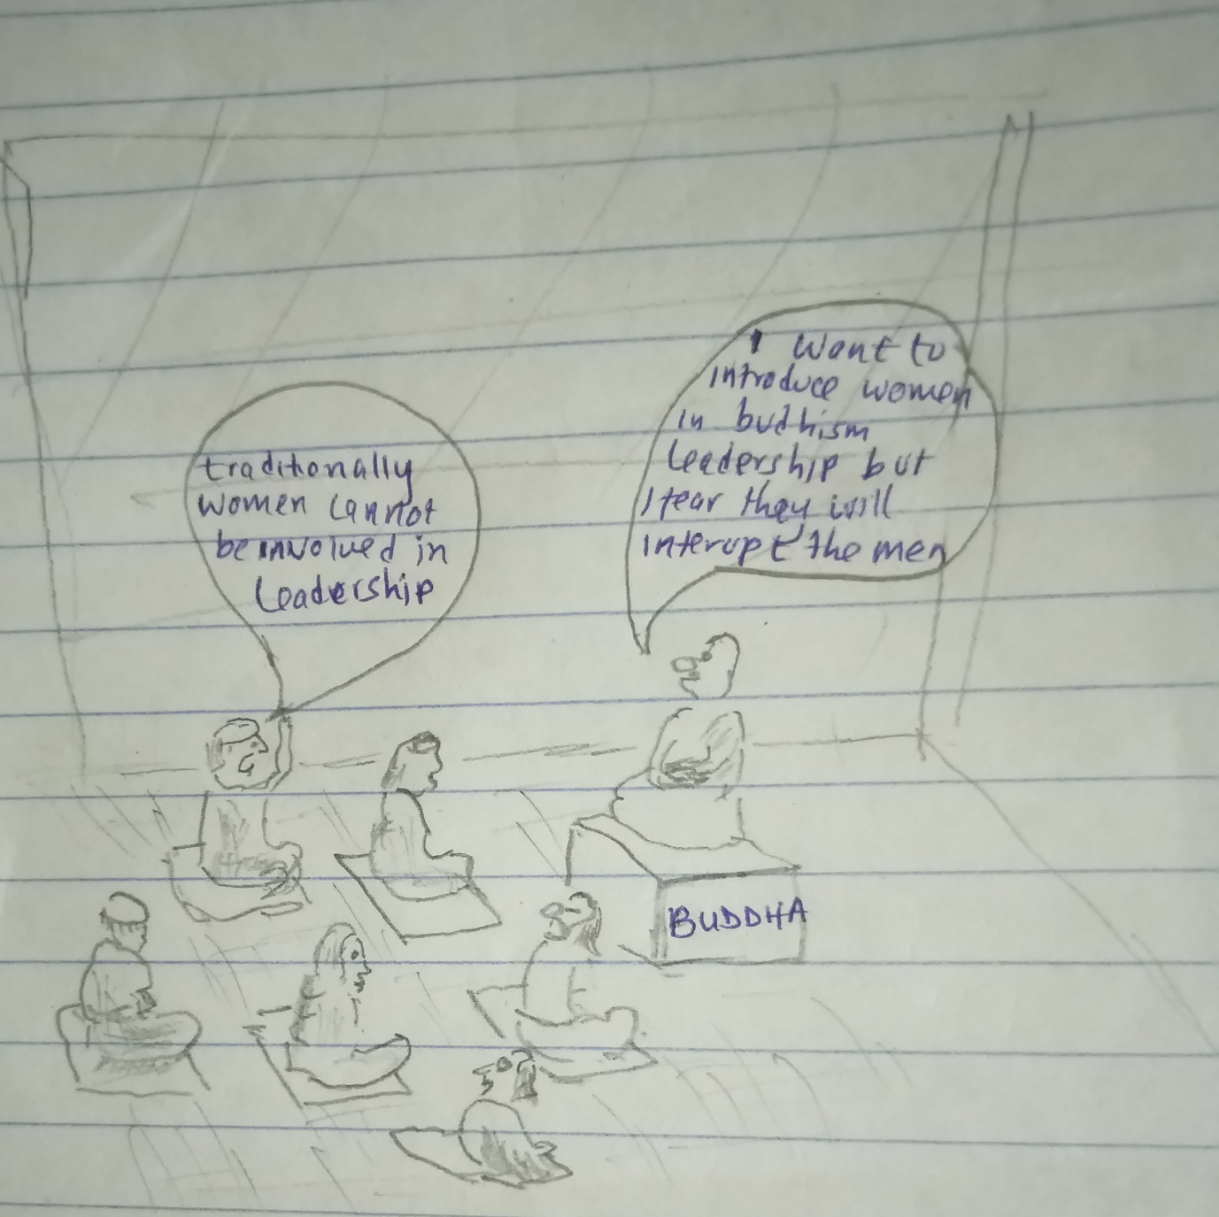
Fig 3: Carton critiquing Buddhism

